1. Hardware

General hardware notes:

* The hardware below is based on the component list provided in Table S. Additional miscellaneous needed equipment include: Plasti Dip or epoxy to waterproof the hardware, heat-shrink tubing to seal the wires, and general soldering equipment.
* Adding heat-shrink tubing over soldered tips on the peralstatic hydraulic water pumps is recommended to waterproof + provide extra security.
* The additional box provided for the storage of Vanadium III Chloride needs to be constantly chilled at a temperature of at least 3 C, so instructions to create the insulated box will be given. In the current design, the ice packs within the box must be changed every 5 days.
* Part of the manual maintenance also includes running distilled water through the entire system approximately after 15 runs when using soil samples, in order to avoid contamination. It can differ though, depending on how high concentrations of nitrate are, and observations users make while using it themselves.

1.1 Assembling the mechanics/ wiring portion of the hydraulics portion of the device

1.1.1. Create the PCB according to Fig 3 in the format of Fig 1. Fig 3 is the circuit diagram of the PCB, and Fig 1 shows the finished product look. Fig 4 shows how the PCB looks in real life.

1.1.2. Connect the wires of all the unidirectional vacuums to their respective pins, as shown in Fig 1 through the vacuum number labels, with red going to P (power) and ground going to G for each respective vacuum number.

1.1.3. Connect all the wires of the bidirectional vacuums to their respective pins, as shown in Fig 1, with red going to P and ground going to G

1.2 Assembling the tubing of the hydraulics portion of the device

1.2.1. Solder red and black wires onto each of the 6 peralstatic hydraulic water pumps power line, and ground. The power line is marked by a red + sign next to it. Make sure the wires are significantly long, so that they won’t fall too short when connecting to the PCB. They may be too long, in which case, they can be cut short during that step.

1.2.2. Each water pump comes with two tubes, one slightly longer than the other. Connect the first peralstatic hydraulic water pump’s longer tube to the 173cm pipe ending with the ceramic suction cup tube using a 1/16th’ tube connector. Put

1.2.3. Connect the shorter tube of the first peralstatic hydraulic water pump to a 30 cm length 1/16th’ inner diameter tubing

1.2.4. Connect the longer tube of the second peralstatic hydraulic water pump to a 55 cm length 1/16th’ inner diameter tubing

1.2.5. Connect the shorter tube of the second peralstatic hydraulic water pump to a 40 cm length 1/16th’ inner diameter tubing

1.2.6. Connect the longer tube of the third peralstatic hydraulic water pump to a 40 cm length 1/16th’ inner diameter tubing

1.2.7. Connect the shorter tube of the third peralstatic hydraulic water pump to a 40 cm length 1/16th’ inner diameter tubing

1.2.8. Connect the longer tube of the fourth peralstatic hydraulic water pump to a 70 cm length 1/16th’ inner diameter hard shell tubing

1.2.9. Connect the shorter tube of the fourth peralstatic hydraulic water pump to a 55 cm length 1/16th’ inner diameter hard shell tubing

1.2.10. Connect the longer tube of the fifth peralstatic hydraulic water pump to a 40 cm length 1/16th’ inner diameter tubing

1.2.11. Connect the shorter tube of the fifth peralstatic hydraulic water pump to a 35 cm length 1/16th’ inner diameter hard shell tubing

1.2.12. Connect the longer tube of the sixth peralstatic hydraulic water pump to a 30 cm length 1/8th’ inner diameter tubing

1.2.13. Connect the shorter tube of the sixth peralstatic hydraulic water pump to any length 1/8th’ inner diameter tubing, depending on where you prefer the sample collected to be deposited back to soil.

1.2.14. Set up 2 test tube holders, each with 2 spots for test tubes. If possible to buy, then recommended to buy that. Otherwise, buy a 4 test tube holder and split in half.

1.2.15. In the first test tube holder, set up the 50 ml test tube with the non-contact water level sensor set at the 5 ml point.

1.2.16. In the second test tube holder, put two test tubes, filling up both spots. The first being a 15 ml test tube and the second being a 50 ml test tube (T2 and T3).

1.2.17. Put rubber corks into all three test tubes. Prior to doing so, drill a big enough hole to fit at least 3, 1/16th’ inner diameter tubing. In order to secure the shape of the drilled hole, it is recommended to use some sort of larger plastic tubing such as the straw in shampoos or pen refills, and use that as the encapsulating tube within the cork.

1.2.18. Put the tubes from the shorter end of the first vacuum along with the longer end of the sixth vacuum and the longer end of the second vacuum into the first test tube (marked T1 in Fig 2): the one with the water-level sensor. The sixth vacuum’s pipe should go to the very bottom of the T1.

1.2.19. Put the tubes from the shorter end of the second vacuum, shorter end of the fourth vacuum, and the longer end of the third vacuum in test tube 2 (T2 in Fig 2). The pipe from V3 should be all the way at the bottom of the tube (VERY IMPORTANT).

1.2.20. The pipe from the fourth vacuum should be above the 10 ml mark in T2 because when it reverses the vacuum direction in order to clear the piping, it should not remove any of the mixed reagent + pore water sample and contaminate the reagent stock, as well as ruin the cycle’s reading.

1.2.21. An important thing to consider here is that 100 microliters of sample is an incredibly small amount of pore water. Hence, in order to make sure it is an accurate amount of sample, position the pipe from the second vacuum in T2 to be at the level of 100 microliters in the test tube (use a pipette’s measurement to get the exact height). The code deposits 500 microliters from that pipe, but then removed 400 by reversing the direction of the vacuum. This allows exactly 100 microliters to be deposited.

1.2.22. The longer end tube of the fourth vacuum goes to the reagent. Make a hole in the main box, and make a hole in the cap of the reagent. Fit the tubing through that (Reference those steps in 1.5).

1.2.23. Fit a cork with two holes into a cuvette. Put the shorter pipe from the third vacuum into one of the holes in the cuvette, but only a little bit. It should just peek out of the bottom of the cork, no further down than that.

1.2.24. Fit the longer pipe of the fifth vacuum into the second hole of the cuvette, but this one should be pushed along the side of the cuvette, all the way to the bottom. It should not be in the middle of the cuvette, otherwise it interferes with the light passed through during the spectrophotometer portion of the device. Make sure to test this part thoroughly because it takes some trial and error to get the perfect position of the pipe

1.2.25. Put the shorter tube of the fifth vacuum into the third test tube (T3 in Fig 2).

1.2.26. After all the tubes have been properly fitted, seal them in place with epoxy or PlastiDip. Electrical tape can also be used, but not recommended for long-term use.

1.3 Connecting the spectrophotometer portion of the device

1.3.1. Connect the curved connector strip of female to male headers to the spectrophotometer pins

1.3.2. Take 8 different colored wires with female headers on one end and male headers on the other side

1.3.3. Connect the female header side of the wires to the header male pins on the spectrometer

1.3.4. Connect the male headers of the wires to the matching labels for each [jutting] as written on the spectrophotometer to the [places] shown in Fig 1

1.3.5. 3D print the black box required for the spectrophotometer from this link: (<https://osf.io/rbfse/>) under the 3D printed section. Do not print the top cap, it is unnecessary

1.3.6. Cut a small vertical rectangle shape into the 3D printed box where the spectrophotometer fits, near where the cuvette is inserted.

1.3.7. Make the hole on the side slightly bigger (all the female header wires connected to the spectrometer will be channeled through there as well as the LED wires)

1.3.8. Fit the spectrometer into the 3D printed box, with the side the female headers are connected to, facing upwards

1.3.9. Channel all the spectrometer wires through the enlargened hole on the side

1.3.10. Cut a small soldering board, the height of the inside of the 3D-printed black box

1.3.11. Solder an LED to the middle of it and solder a red and black wire to the positive and negative connections of the LED on the soldering board

1.3.12. Fit the LED in the middle of the 3 LED bulb compartments in the 3D printed black box where the cuvette is inserted

1.3.13. Channel the LED wires through the enlarged hole on the side of the box

1.3.14. Solder the red LED wire to pin 18 on the PCB as seen in Fig 4

1.3.15. Fit the two-hole neoprene stopper into the top of the cuvette (requires some filing because it is not a perfect fit: stopper is slightly too big at the bottom)

1.3.16. Put the lid of the black box and then insert the cuvette with the cork into the compartment for the cuvette

1.4. Prior to deploying the device in the field, test to measure that the correct amount of sample and reagent is being deposited. Sometimes, device to device, depending on how the tubes are angled, it can take longer or can be slower. Measure by yourself once with the timings in the code and adjust if necessary

1.5. Making the Reagent Box

1.5.1. Take a large insulated white box made of styrofoam and make a hole on the side

1.5.2. Fit the hose connector in the hole and pull the longer tube of the fourth vacuum through the hole in the main box and through the hole in the white box and through the hole on the reagent bottle’s cap

1.5.3. Fig 6 shows the insulated box next to the device in the field

2. Software

The code for the device can be found in a GitHub repository at the following link: <https://github.com/SahitiB/AGNET/tree/main>.

The code contains comments to explain each code section’s purpose and provides the end-user with the opportunity to test and adjust the system according to specific needs or issues. For more general information regarding open-source hardware programming, multiple sources and tutorials can be found on the internet. The sequence of events in the code can be understood using the flowchart in Figure 5.

Table S:

| **Component** | **Cost($)** | **Source of Materials** | **Comments** |
| --- | --- | --- | --- |
| Arduino Mega 2560 | $48.99 | Amazon | [https://www.amazon.com/gp/product/B0046AMGW0](https://www.amazon.com/gp/product/B0046AMGW0/ref=ppx_yo_dt_b_search_asin_title?ie=UTF8&psc=1) |
| DS1307 RTC Module | $1.32 | Amazon | [https://www.amazon.com/DAOKI-Arduino-AT24C32-Precision-Compatible/dp/B07XB2265S](https://www.amazon.com/DAOKI-Arduino-AT24C32-Precision-Compatible/dp/B07XB2265S/ref=sr_1_4?crid=1E8EN73GHW5CT&keywords=DS1307+RTC+Module&qid=1688574962&sprefix=ds1307+rtc+module%2Caps%2C201&sr=8-4) |
| L293D Motor Driver (x2) | $0.89/unit | Amazon | https://www.amazon.com/BOJACK-16-pin-Stepper-Drivers-Controllers/dp/B09NBQVYLL/ |
| IC 7805 voltage regulator IC | $0.70 | Amazon | [https://www.amazon.com/Chanzon-Three-Terminal-Positive-Regulator-Transistor/dp/B083TBMJJS](https://www.amazon.com/Chanzon-Three-Terminal-Positive-Regulator-Transistor/dp/B083TBMJJS/ref=sr_1_2_sspa?crid=UROIA7S3G7CW&keywords=IC+7805+voltage+regulator&qid=1693878074&sprefix=ic+7805+voltage+regulator%2Caps%2C406&sr=8-2-spons&sp_csd=d2lkZ2V0TmFtZT1zcF9hdGY&psc=1) |
| Micro SD TF Card Adapter | $1.40 | Amazon | [https://www.amazon.com/HiLetgo-Adater-Interface-Conversion-Arduino/dp/B07BJ2P6X6](https://www.amazon.com/HiLetgo-Adater-Interface-Conversion-Arduino/dp/B07BJ2P6X6/ref=sr_1_1_sspa?crid=9EW3KVH6T0U2&keywords=Micro+SD+TF+Card+Adapter+arduino&qid=1688575053&sprefix=micro+sd+tf+card+adapter+arduino%2Caps%2C173&sr=8-1-spons&sp_csd=d2lkZ2V0TmFtZT1zcF9hdGY&psc=1) |
| SanDisk 32GB Micro SD Card Class 10 | $8.10 | Amazon | https://www.amazon.com/SanDisk-Ultra-UHS-I-Memory-Adapter/dp/B00M55C0NS |
| Warm White Diode (LED) | $0.07 | Amazon | https://www.amazon.com/Transparent-Lighting-Electronics-Components-Emitting/dp/B01AUI4VRE/ |
| 0.01 micro Farad Capacitors (x20) | $0.15/unit | Anchor Electronics | Local store in Sunnyvale, California |
| 10 microfarad/25V Capacitor | $0.95 | Anchor Electronics | Local store in Sunnyvale, California |
| 33 micro Farad/50V capacitor | $0.95 | Anchor Electronics | Local store in Sunnyvale, California |
| 4.7K ohm resistor | $0.10 | Anchor Electronics | Local store in Sunnyvale, California |
| DC Power Jack | $0.51 | Anchor Electronics | Local store in Sunnyvale, California |
| 1N4446 Diode | $0.15 | Anchor Electronics | Local store in Sunnyvale, California |
| 4 Pin Screw Terminal | $0.32 | Amazon | https://www.amazon.com/Molence-Terminal-Connector-Terminals-26-18AWG/dp/B09F6TC7RP |
| 2 Pin Screw Terminal (x5) | $0.32/unit | Amazon | https://www.amazon.com/Molence-Terminal-Connector-Terminals-26-18AWG/dp/B09F6TC7RP |
| LEDs (2x Blue, 2x Green, 3 RED, 2 Yellow) | $0.03/unit | Amazon | https://www.amazon.com/gp/aw/d/B073QMYKDM |
| 10K ohm resistors (x10) | $0.10/unit | Anchor Electronics | Local store in Sunnyvale, California |
| Coin cell CR2032 | $0.50 | Amazon |  |
| Soldering wire 50g | $8.99 | Amazon |  |
| Non Contact Water Level Sensor | $14.98 | Amazon | [https://www.amazon.com/gp/product/B07FC8K28F](https://www.amazon.com/gp/product/B07FC8K28F/ref=ppx_yo_dt_b_search_asin_title?ie=UTF8&psc=1) |
| Hamamatsu Micro-spectrometer C12880MA | $350 | Digikey | <https://www.digikey.com/en/products/detail/groupgets-llc/BO-HAMA-C12880-V2-SENSOR/14306449> |
| Semi-micro spectrophotometry Cuvette | $0.32 | UC Davis Lab | Item is like this one from Amazon: [https://www.amazon.com/BrandTech-759076D-Polystyrene-Semi-Micro-Spectrophotometry/dp/B003UTUPQ2](https://www.amazon.com/BrandTech-759076D-Polystyrene-Semi-Micro-Spectrophotometry/dp/B003UTUPQ2/ref=sr_1_20?keywords=cuvette&qid=1688573150&sr=8-20) |
| 3D printed custom box for cuvette/ spectrometer | $70 | Simple Machining | Provided the .STL file and got it 3D printed in a local store in Livermore, CA. |
| QILIPSU Junction box: size = 8.6 x 6.7 x 4.3 inches | $26.99 | Amazon | <https://www.amazon.com/gp/product/B085QCT543> |
| QILIPSU Junction box: size = 16.1"x12.2"x7.1 | $68.99 | Amazon | <https://www.amazon.com/gp/product/B08ZRR2DJX> |
| 4 Test tube rack | $9.86 | Amazon | <https://www.amazon.com/gp/product/B07D4H1CBH/ref=ppx_yo_dt_b_search_asin_title?ie=UTF8&th=1> |
| Rubber corks |  |  |  |
| Two-hole Neoprene Stopper for Cuvette | $16.99 | Amazon | <https://www.amazon.com/gp/product/B07DRSM165/ref=ppx_yo_dt_b_search_asin_title?ie=UTF8&psc=1> |
| Peralstatic Hydraulic Water Pumps (x6) | $11.98/unit | Amazon | <https://www.amazon.com/gp/product/B01IUVHB8E/ref=ppx_od_dt_b_asin_title_s00?ie=UTF8&psc=1> |
| Ceramic suction cup |  | Davis |  |
| 12V 7.0 Ah Lead acid battery | $38.97 | Homedepot |  |
| 100-1000 microliter pipette | $33.99 | Amazon | <https://www.amazon.com/gp/product/B087BYJV6S/ref=ppx_od_dt_b_asin_title_s00?ie=UTF8&th=1> |
| 10-100 microliter pipette | $33.99 | Amazon | <https://www.amazon.com/gp/product/B083KGZ7SJ/> |
| Pipette tips for both pipettes | $9.97 | Amazon | <https://www.amazon.com/gp/product/B01HHDCT1A> |
| Hose connectors (1/8” x 1/8”) | $8.98 | Amazon | <https://www.amazon.com/gp/product/B093GR5CD1> |
| Hose vinyl tubing 16ft | $9.49 | Amazon | <https://www.amazon.com/gp/product/B09GV1KDFB> |
| Centrifuge Tubes 50mL (x4) | $0.64/count |  | <https://www.amazon.com/Leak-Proof-Centrifuge-Graduated-Container-sterilized/dp/B07F8RQYQ6> |
| Cable clamps (18 pack) | $1.74 | Home Depot |  |
| Single Row Curved Connector Pin Header Strip | $8.99 | Amazon | <https://www.amazon.com/uxcell-Single-Connector-Arduino-Prototype/dp/B07FFZRQ47/ref=sr_1_1?crid=1K1PY58DNJD2G&keywords=single+row+curved+connector+pin+header+strip+female+to+male&qid=1694890734&s=electronics&sprefix=single+row+curved+connector+pin+header+strip+female+to+mal%2Celectronics%2C184&sr=1-1> |
| Hard shell tubing 1/16th inner diameter with female and male tube connectors |  | Davis |  |
| Styrofoam White box | $46.99 | Amazon/ UC Davis | <https://www.amazon.com/Boxes-Fast-BF230C-Insulated-Container/dp/B077BXWCX6/ref=sr_1_14_sspa?crid=1WCKS17TKBR0Z&keywords=styrofoam+white+box+large&qid=1694904460&sprefix=styrofoam+white+box+larg%2Caps%2C256&sr=8-14-spons&sp_csd=d2lkZ2V0TmFtZT1zcF9tdGY&psc=1> → this is quite a large box, and is not required if cheaper options are found. |

Figure 1:

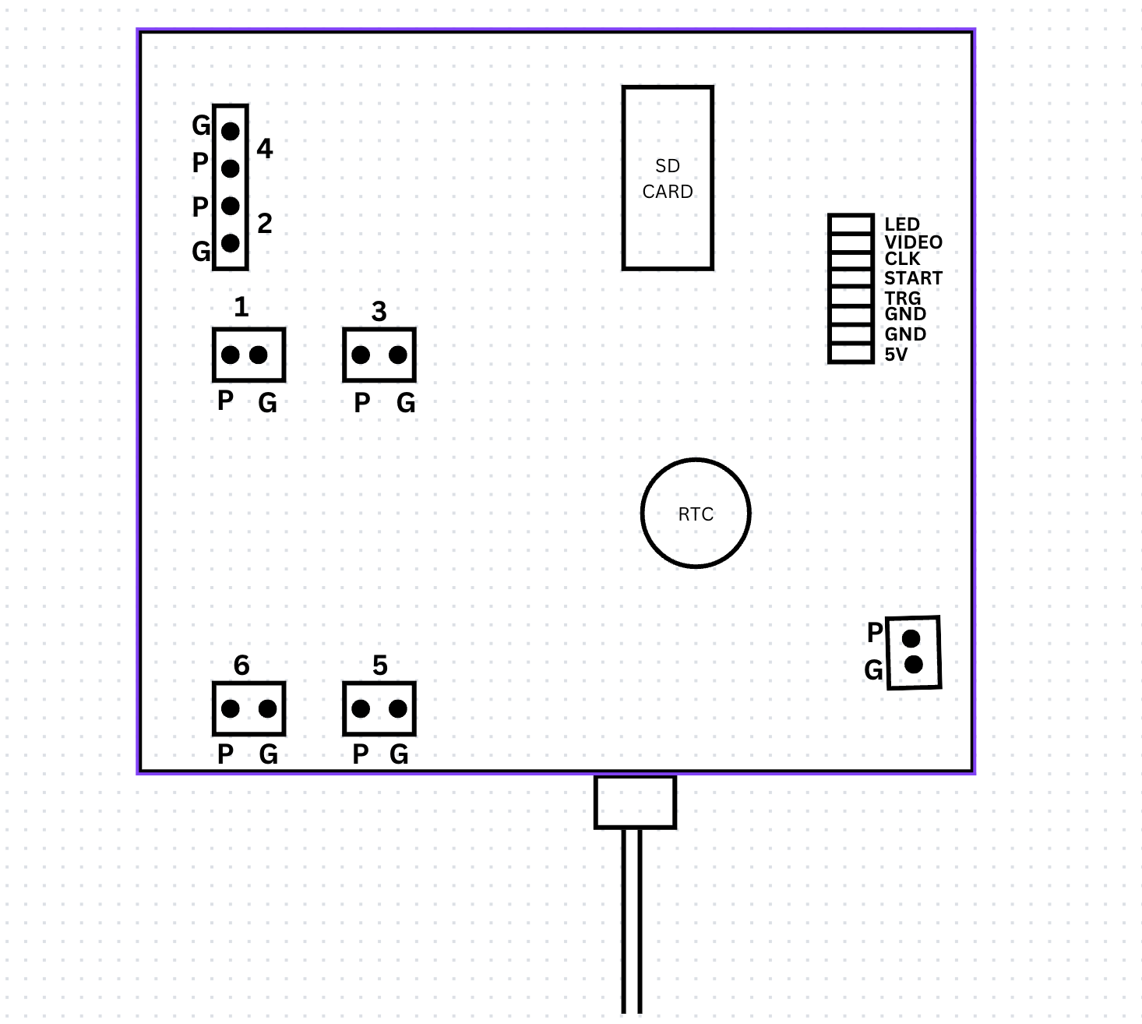

Figure 2:

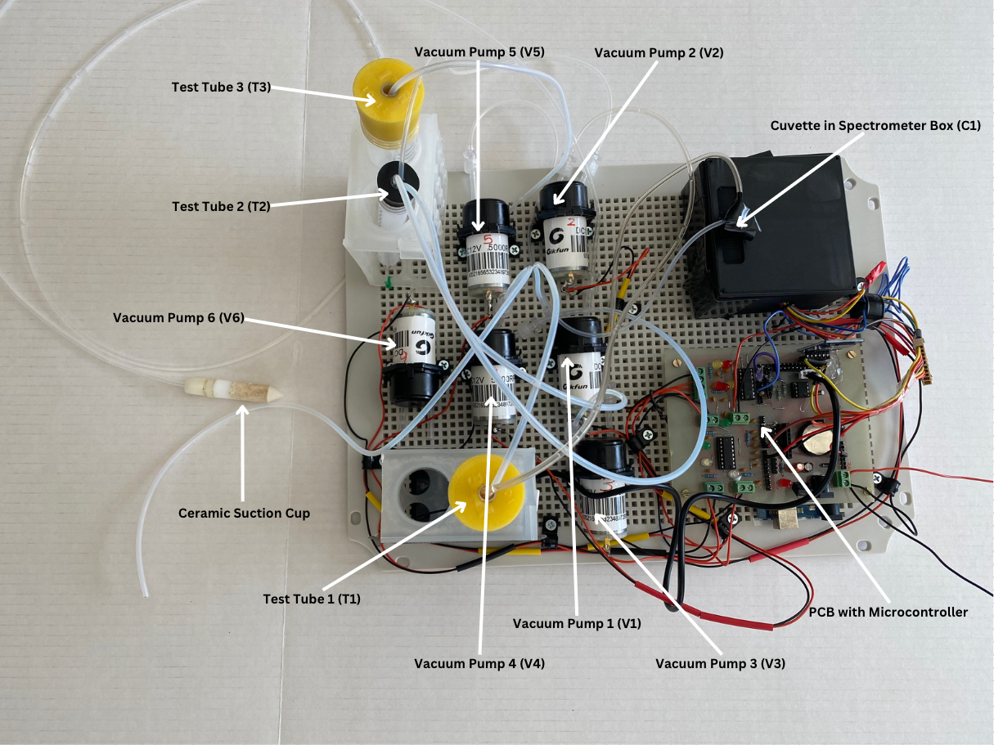

Figure 3:

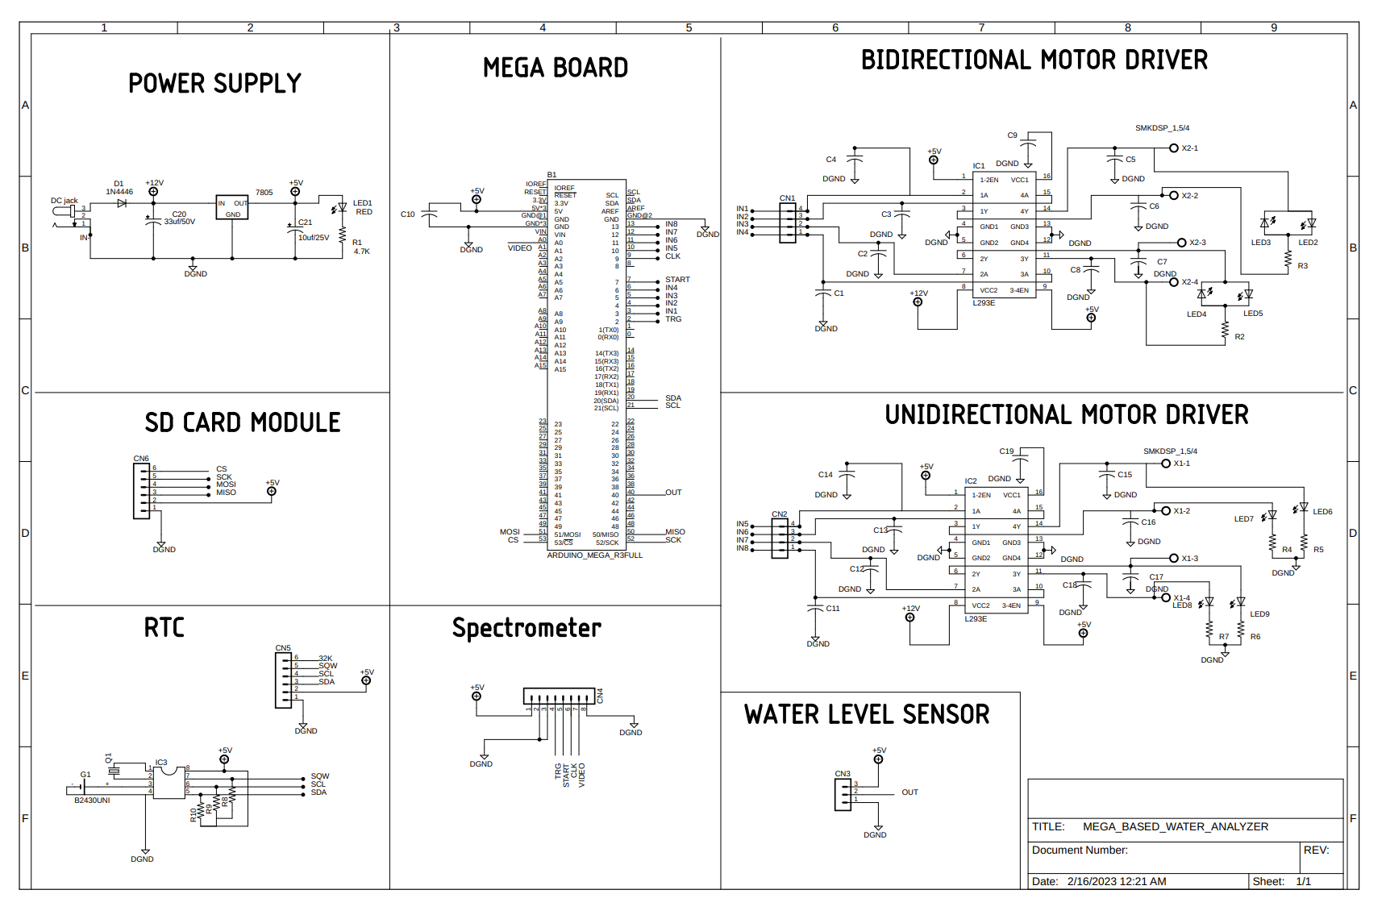

Figure 4:

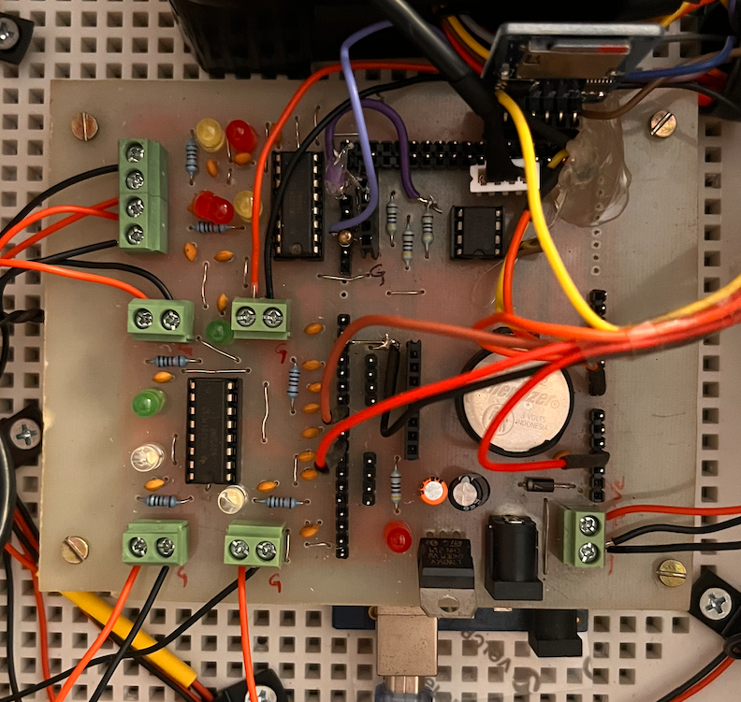

Figure 5:

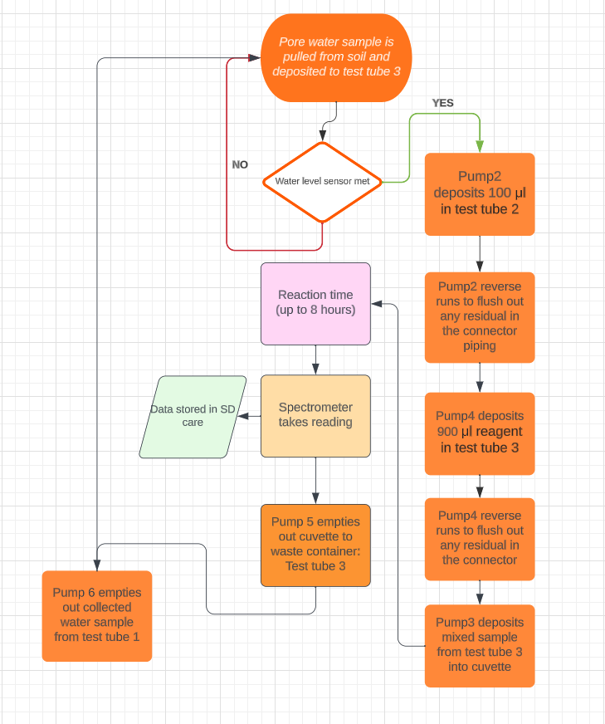

Figure 6:

